The Double Bind of Increasing Clinic Efficiency:

A New Model Offers Opportunities to Build Resilience of Systems and Individuals

Topic Area(s)

* Sustainable models of care;
* Leadership and governance;

Please specify your project approach

Mitigation only

Key message / aim

Healthcare delivery generates substantial waste and emissions, and our understanding of the environmental impact of our clinical practices is growing. Metrics that account for planetary health and harm are not yet widely considered in the valuation of health services. Currently, cost and compensation are powerful drivers of both patient and clinician behavior. To inspire sustainable changes in our current healthcare delivery systems, we must first reckon with our current valuation models. By considering such questions through a new lens, we may envision opportunities to inspire and reinforce changes in individual habits and system performance.

What was the problem?

Methods for measuring the value of healthcare delivered by clinicians and health systems are evolving. Historically, fee-for-service models encouraged a focus on increasing the volume of services delivered to patients. Value-based programs attempt to balance quantity, quality and cost while improving the patient experience. While well-intended, our historic focus on linear growth of clinic volume and productivity has not led to increased access to care for all populations. It has also perpetuated inequality in who bears the burden of our practice patterns. Envisioning the health systems of the future requires consideration of both efficiency and resilience and an awareness of the potential unintended consequences of our metrics of success.

What was the solution?

Causal loop diagrams (CLD) serve as a powerful tool for modeling complex relationships in the economic and sustainability sectors. They offer an alternative to linear growth-focused models and instead highlight stakeholder inter-relatedness and opportunities for iterative adaptation. Applying such a model to the metric of number of patients scheduled each day in clinic (clinic throughput) yields multiple reinforcing and balancing loops. The role of and impact on each party are reviewed to demonstrate the interrelationships between patients, clinicians, clinic staff, and health systems (see Figure 1). This method is helpful in answering questions about how throughput impacts access to care, education, and wellbeing of stakeholders in a medical clinic.

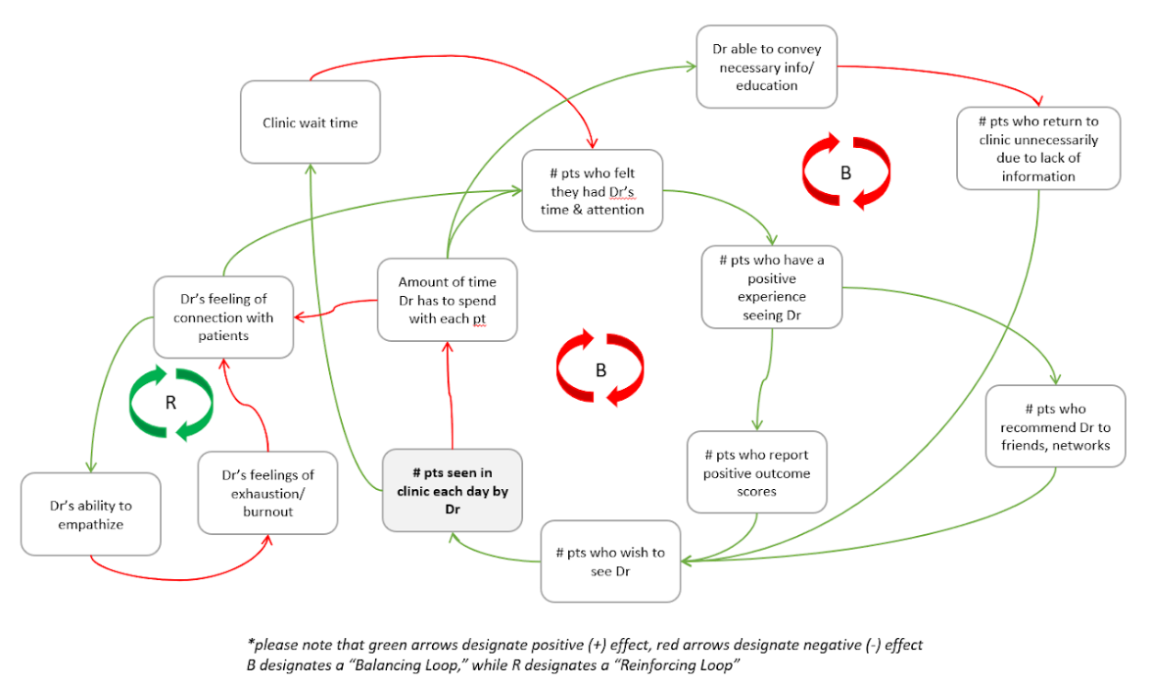

Figure 1: Causal Loop Diagram models impact of increasing clinic throughput as measured by number of patients seen per day.

What were the challenges?

Building health system resilience requires a transformative approach to the current valuation models for healthcare delivery. If we cannot reconcile our current focus on profits and productivity with the wellbeing of all people and our planet, we will be forced to mitigate the far-reaching and irreversible consequences of climate change.

What helped the intervention implementation/success?

Awareness of the high incidence of depression, anxiety, burnout, and suicidality amongst physicians is growing. Members of our younger workforce are increasingly concerned with wellbeing and mental health. Sustainable healthcare delivery must account for such concerns, and this model provides a means of assigning value to clinician wellbeing, emotional connections, burnout, and fatigue.

What were the results/Impact?

Patient outcomes:

Utilizing an alternative model to assess clinic throughput, one is able to place value on current system shortcomings. The number of patients seen by a physician each day must be weighed against the benefits of decreased wait times, increased time spent on patient education, and improved physician-patient connection and engagement.

Population outcomes:

The climate in which we practice clinical medicine is increasingly complex and varied across the globe. The COVID pandemic revealed the fragility of many of our social and economic structures, and inequality continues to rise. Utilizing this CLD model and projecting its accuracy in and impact on varied clinical scenarios reveals that physicians and their patients are both victims and perpetrators of a system that rewards efficiency alone. Rather than taking a linear approach to clinic throughput, CLD’s offer a more intentional and inclusive model of healthcare delivery.

Environmental impact:

The proposed model aims to build health system resilience. It also provides an alternative to production-focused metrics that are known to generate excessive waste and emissions.

Social impact:

This model serves as an introduction to how clinicians can take a leadership role in rethinking outdated systems. The impacts of such a shift on resources, patient outcomes, innovation, and education would be far-reaching. Along with developing more resilient clinical systems, such examples also allow us to better understand and tackle clinician burnout and improve patient and caregiver literacy and empowerment.

Financial impacts:

The proposed model invites readers to consider alternatives to our current healthcare delivery compensation structures. It does not provide a roadmap or a universal pathway for transformation, but instead provides a framework for individuals and health systems to assess clinic throughput with a new focus on resilience rather than volume.

What were the learning points?

CLD mapping offers an opportunity to consider the intangible impacts of current clinical practices on clinicians and patients.

Next steps

The author hopes to share the CLD model with readers as a tool for assessing their practices in a more holistic manner. Research is ongoing to apply the model to more specific clinical scenarios. Further considerations could be included in the proposed model to make it more inclusive of individual and system concerns.

Want to know more?

Contact name:Laura L. Bellaire MD

Role:Assistant Professor

Contact details:laura.bellaire@hsc.utah.edu

Location & Region:Salt Lake City, UT, USA

Has this case study or story been made public in any form before?No

Resources and References

Harvey SB, Epstein RM, Glozier N, Petrie K, Strudwick J, Gayed A, Dean K, Henderson M. Mental illness and suicide among physicians. Lancet. 2021 Sep 4;398(10303):920-930. doi: 10.1016/S0140-6736(21)01596-8. PMID: 34481571; PMCID: PMC9618683.