Post Climate Emergency Declaration Comms Pack

“Can anybody still deny that we are facing a dramatic emergency?... I call on all leaders worldwide to declare a State of Climate Emergency in their countries until carbon neutrality is reached.”
The UN secretary-general, Antonio Guterres

Trust/Royal College Press Release
Example Quotes from Chief Executives & Presidents:
- "We want to publicly acknowledge the huge threat of climate change, do as much as possible to tackle it ourselves and, as anchors in our community, encourage collaborative action."
Andrea Young, North Bristol NHS Trust Chief Executive. See full quote here

- “The NHS has recognised climate change as the greatest threat we face to our health and wellbeing. This is urgent and we need to act now. The NHS has always been a strong advocate for social justice and it is critical that we respond to this threat to our way of life.”
Lord Peter Smith, chair of the Greater Manchester Health and Social Care Partnership. See full quote here
- "Preventing avoidable illness, promoting health and wellbeing and being operationally resilient are all fundamental to the future of the NHS. The quicker we can take action on climate change, the quicker we'll improve the health of people right now as well as for future generations."
Robert Woolley, University Hospitals Bristol NHS Foundation Trust Chief Executive. See full quote here
- “Climate change is not just an environmental issue, there is now good evidence that climate change is the greatest threat to public health in the 21st century.”
Deborah Lee, Gloucestershire Hospitals NHS Foundation Trust Chief Executive. See full quote here
- “The climate emergency is a health emergency, with doctors and other clinicians already seeing the impacts associated with air pollution, rising temperatures and extreme weather events on the patients they treat. Climate change isn't something we can afford to delay acting on...Hospitals also have an opportunity to use their influence as key anchor institutions in local communities to drive positive change beyond their walls."
Professor Andrew Goddard, Royal College of Physicians president. See full quote here

Photo Op
In a Covid secure way! E.g. Photo frame with Health Declares Logo & 1-2 healthcare professionals in the frame
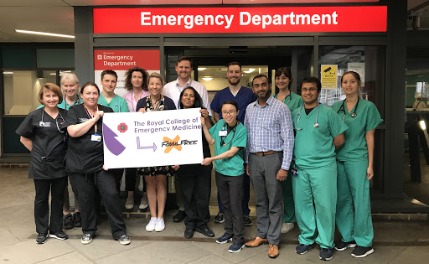

Video
The Royal Cornwall Hospitals Trust has declared a Climate Emergency: https://twitter.com/i/status/1322527411179868163

Tweets
Suggested Tweet:
“The climate crisis is a health crisis. That’s why today we are declaring a climate & ecological emergency and committing to taking action. The quicker we can take action on climate change, the quicker we'll improve the health of people now as well as for the future - ensuring a safer & fairer future for all. #healthdeclares”

Remember to tag @healthdeclares so we can amplify your voice.

Badges/Cards
- Every member of the trust given “Climate Crisis = Health Crisis” badge

