Heatwave preparedness – and primary care
Bhavita.Vishram@barnet.gov.uk and Angharad.Shambler@haringey.gov.uk
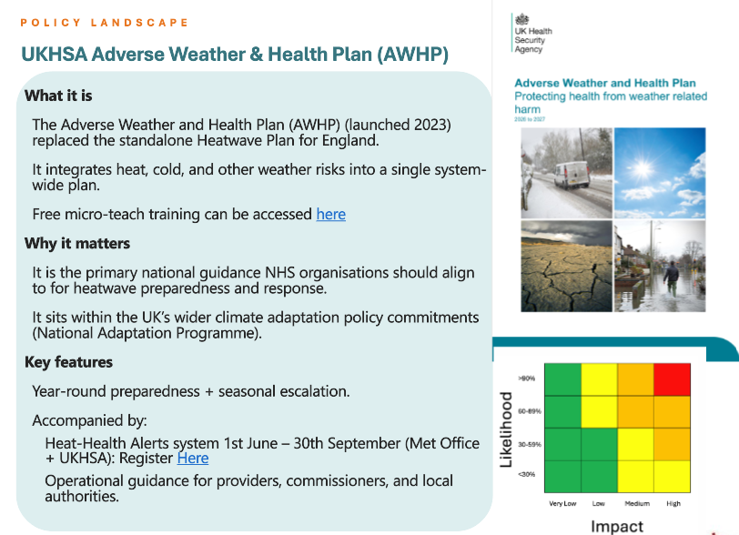

Public library - UKHSA national - Knowledge Hub
Weather-Health Alerting system registration form
Heat-Health Alerting system - GOV.UK

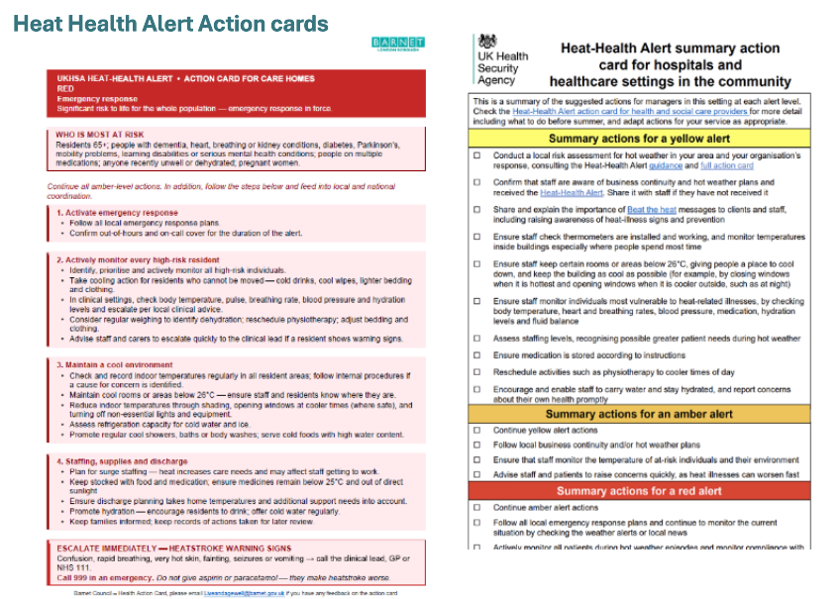
Heat health action cards can be adapted for local use and resources

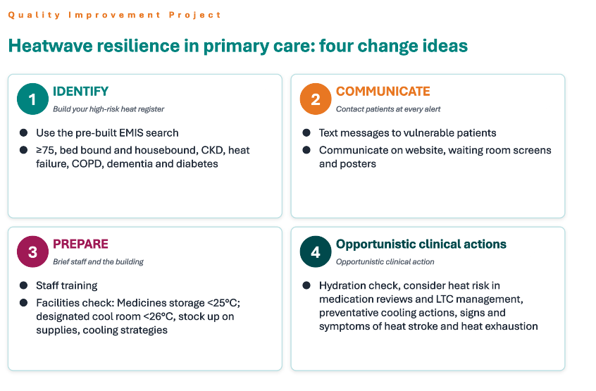
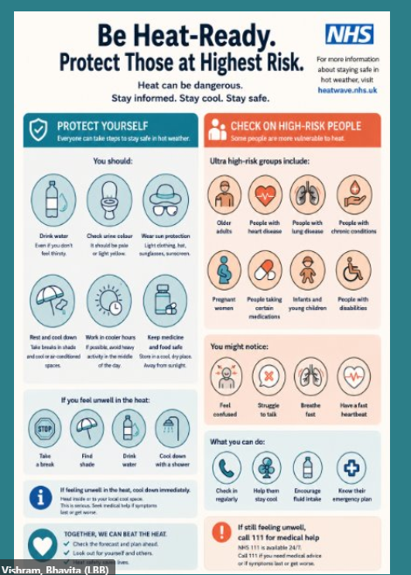
Example poster

Heat can harm - Keeping cool in summer | Barnet Council
See Resources for ‘Heat can harm’ posters e.g. Barnet Extreme Heat Campaign_LONG TERM HEALTH

