SUSQI PROJECT REPORT
Improving Liver Function Test Utilisation in Clinical Practice
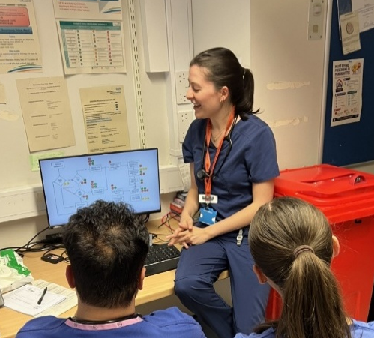
Start date of Project: April 2026
Date of Report: 24th of August 2026
Team Members:
- Dr. Paola Christina Sommerhalder Nava – Internal Medicine Core Trainee, paola.nava@uhliverpool.nhs.uk
- Holly Millington – Gastroenterology Advanced Medical Practitioner, holly.pleavin@nhs.net
- Dr. Kathleen Handley – Foundation Year One Resident Doctor, kate.handley5@nhs.net
- Dr. David Morgan – Foundation Year One Resident Doctor, david.morgan60@nhs.net
- Imogen Lyons – Head of Continuous Quality Improvement, imogen.lyons1@nhs.net
- Dr. Lalitha Chinnappan – Gastroenterology Consultant and Associate Medical Director for Patient Safety, lalitha.chinnappan@nhs.net
Problem:
The overutilisation of liver function tests (LFTs) in the inpatient setting, particularly inappropriate repeat testing at intervals shorter than the 72-hour minimum recommended by the Royal College of Pathologists (2021), contributes to unnecessary healthcare costs and environmental impact.
Background:
Unnecessary laboratory testing is a common problem in healthcare, with international studies estimating that up to 30–60% of tests are unnecessary (Koch et al., 2018; Barratt et al., 2022). This issue also affects the UK, where over a billion tests are performed by hospitals each year (Royal College of Pathologists, 2021), with at least a quarter found to be unnecessary repeats and only a third having an impact on patient management (Carter, 2006).
It is well documented that unnecessary testing can lead to patient harm through false-positive results, which may trigger a diagnostic cascade of further unnecessary interventions, overdiagnosis, anxiety, and overtreatment (Müskens et al., 2022). It can also result in direct and indirect costs for healthcare services by diverting resources from other departments and creating additional workload for healthcare professionals (Hale and Green, 2025).
Furthermore, unnecessary investigations carry a significant environmental cost due to the energy and resources required to perform them (Barratt et al., 2022). Although the environmental burden of unnecessary blood testing in the UK remains unknown, the NHS contributes approximately 4–5% of the UK's carbon emissions (Tennison et al., 2021), making the reduction of unnecessary investigations an important component of efforts to reduce the healthcare system's carbon footprint (NHS England, 2025).
To understand the true burden of unnecessary testing specifically for LFTs, we investigated the impact of a single unnecessary LFT across several areas.
What is the environmental burden of one LFT?
The estimated carbon emission of a single LFT is approximately 383 g CO₂e (Spoyalo et al., 2023), equivalent to the emissions from driving 1–2 miles in a small petrol car or using an electric kettle for approximately 20 minutes (Carbon Footprint Ltd, no date).
What is the financial burden of one unnecessary LFT?
The cost of a single LFT was reported to be £2.47 at Leighton Hospital (Kannan, Mathew and Griffith, 2025), a district general hospital similar to ours within the same region of Mersey in the Northwest of the UK.
What is the clinical burden of one unnecessary LFT?
As discussed above, unnecessary testing can trigger diagnostic cascades, the direct and indirect costs of which are impossible to quantify as they vary considerably between cases. However, one important consideration specific to LFTs is that approximately 22% of the general population have abnormal LFTs (Schreiner et al., 2018). Current recommendations advise that adults with abnormal liver blood tests should be referred to, or at least discussed with, a gastroenterologist for further evaluation (Newsome et al., 2018). Consequently, unnecessary testing adds substantial workload to gastroenterology services, reducing their capacity to identify clinically meaningful findings.
This is particularly important as gastroenterology services are already under significant pressure. Hospital admissions for liver disease have increased by 50% over the last 10 years (British Society of Gastroenterology, 2025), and more than a third of patients spend over 18 weeks on gastroenterology waiting lists (The King's Fund, 2025).
The rising prevalence of liver disease, combined with increasing pressures on gastroenterology services and the growing strain that climate change is placing on an already stretched healthcare system (NHS England, 2025), highlights the need to optimise resource use and promote appropriate testing practices to reduce the financial, environmental, and clinical burden of unnecessary investigations.
Similar projects with the aim of reducing unnecessary testing have been undertaken in the UK. Thurm et al. (2021) reduced unnecessary blood testing at Royal Bolton Hospital, a district general hospital, through educational interventions that prompted clinicians to consider whether the tests they were ordering were clinically indicated. This resulted in a 33% reduction in blood testing and a £7,000 cost reduction over one month, with no significant increase in length of stay or mortality.
Mughal et al. (2016) introduced a vetting system in which senior clinicians reviewed blood tests requested within the General Surgery Department of a district general hospital, with the aim of reducing unnecessary testing in their colorectal unit. The vetting initiative resulted in a 33% reduction in blood test requests, translating to a cost saving of £2,400 over three months, without affecting patient care.
A paediatric ICU at Great Ormond Street Hospital conducted a QIP aimed at reducing unnecessary LFT requests by implementing a form to improve communication between nursing and medical teams. The form guided discussions on which investigations were clinically indicated for each patient. In the eight-month period following implementation, there was a significant and sustained reduction in LFT requests and blood tests overall, resulting in estimated savings of approximately £36,000 (Sinitsky and Brierley, 2017).
Kannan, Mathew and Griffith (2025) inspired this project through their quality improvement project focused on reducing unnecessary LFTs in two medical wards at Leighton Hospital. They identified that almost one-third of LFTs performed on their wards were unnecessary. By introducing minimal retesting intervals through staff emails and posters, they reduced unnecessary testing from 28% to 18%. This resulted in an estimated weekly reduction of 180 kgCO₂e in carbon footprint and a weekly cost saving of approximately £100.
Specific Aims
To reduce the proportion of unnecessary inpatient LFTs by educating clinical staff on the Royal College of Pathologists' minimal retesting intervals, thereby reducing the financial, environmental, and clinical burden of unnecessary testing.
Methods
This quality improvement project was undertaken within the wider medical team at Warrington Hospital, a district general hospital within North Cheshire and Mersey NHS Foundation Trust. The project was piloted across the three inpatient wards with the highest volume of LFT requests: the Acute Medical Unit (AMU), the gastroenterology ward (A5), and the endocrinology and diabetes ward (A2).
The project was delivered collaboratively across multiple departments. The core project team consisted of one Gastroenterology Advanced Clinical Practitioner, one Internal Medicine Core Trainee, and two Foundation Doctors, under the guidance of Dr Chinnappan, Consultant Gastroenterologist and Hepatologist. The hospital's biochemistry, finance, and quality improvement teams also contributed to the project, alongside the clinical leads from each participating ward.
A baseline measurement was undertaken to determine the proportion of appropriate and inappropriate LFT requests across the three selected wards. Data were collected over a two-week period, or until a sample of 100 LFT requests per ward had been reached. LFT requests were classified as inappropriate if they did not comply with the Royal College of Pathologists' (2021) minimal retesting interval guidance; specifically, if they were repeated within 72 hours of the previous test in patients without a strong clinical indication, including acute liver failure, acute poisoning, or total parenteral nutrition.
The process of requesting and processing LFTs was also examined to identify the staff involved. Informal interviews were conducted with clinical and biochemistry staff to develop a process map, detailing the associated use of resources and identifying areas of opportunity.
Following the baseline assessment, a 10–15-minute educational intervention was developed, focusing on the burden of unnecessary LFTs and the Royal College of Pathologists' minimal retesting intervals. Teaching sessions were delivered during Foundation Year 1 teaching, ward morning huddles, and dedicated nursing education sessions to reach most of the staff involved in requesting blood tests. These sessions also provided opportunities for one-to-one discussions with staff to address individual questions and clarify the appropriate indications for repeat testing. Educational posters summarising the minimal retesting intervals were subsequently displayed on each ward to reinforce the key messages.
The Centre for Sustainable Healthcare supported this project by assessing the environmental impact of the processes and materials involved in LFT collection and analysis. Our team provided data on the items used and the processes involved. A cradle-to-grave carbon footprint analysis was then used to estimate the greenhouse gas (GHG) emissions associated with these items. The process was subsequently carbon-footprinted using a process-based carbon footprint analysis.
Measurement
Patient outcomes
The primary patient outcome measure was the proportion of appropriate and inappropriate LFT requests before and after the educational intervention. Appropriateness was assessed according to the Royal College of Pathologists' minimal retesting interval guidance, which defines the timeframe within which repeat testing is more likely to demonstrate a significant change that could influence patient management. By reducing inappropriate repeat testing, we aimed to promote patient-centred care by ensuring investigations were performed only when they were likely to provide meaningful information to support patient management.
Incident reports were also reviewed following implementation of the intervention to assess
whether reducing unnecessary LFT testing had any adverse impact on patient safety. Additional measurements assessing the reduction of patient harm through avoidance of unnecessary diagnostic cascades would have provided further insight, however, these were beyond the scope and available resources of this project.
Environmental sustainability
The Centre for Sustainable Healthcare calculated the total emissions associated with the analysis of a single LFT, including emissions from the energy used to operate the centrifuge and analyse the LFT, each test reagent and its packaging, and sample waste (Table 1.)
Component | Emissions (kgCO₂e per LFT)
Centrifuge | 0.00015 kgCO₂e
Energy use | 0.049 kgCO₂e
Reagent | 0.2795 kgCO₂e
Reagent packaging | 0.0022 kgCO₂e
Sample waste | 0.0127 kgCO₂e
Total emissions per LFT | 0.344 kgCO₂e
Table 1. Emissions associated with the analysis of a single liver function test
The total emissions for analysing a single LFT are 0.344 kgCO₂e. If the blood sample was taken solely for an LFT, emissions from phlebotomy equipment add a further 0.248 kgCO₂e per sample.
The total emissions estimated for a single LFT by the Centre for Sustainable Healthcare differ slightly from those reported by Spoyalo et al. (2023). This difference reflects the calculation being based specifically on the materials, equipment, and processes used at Warrington Hospital. The complete environmental impact report produced by the Centre for Sustainable Healthcare is provided in the Appendix.

Economic sustainability
The biochemistry team provided the cost of each reagent used to perform an LFT panel (Table 2), amounting to approximately 10 pence per test. As LFTs are typically performed alongside other biochemistry tests, the costs of equipment, consumables, staffing, and energy required to collect and process samples were not included, as it was not possible to accurately determine the proportion of these costs attributable to LFTs alone.
Reagent | Cost per reagent (£)
Albumin | £0.010
Alkaline Phosphatase | £0.016
ALT | £0.011
AST | £0.011
GGT | £0.024
Total bilirubin | £0.019
Total protein | £0.005
Total reagent cost per LFT | £0.095
Table 2. Breakdown of reagent costs for an LFT panel at Warrington Hospital
Nonetheless, the North Cheshire and Mersey NHS Foundation Trust Finance Team reported an estimated cost of £1.82 per LFT, representing the cost of the test when performed as a direct access referral from General Practice, which was considered the closest estimate of the inpatient cost per LFT.
Social sustainability
Qualitative and quantitative data were collected through patient and staff surveys conducted across the participating wards. Patient surveys explored views on the frequency of blood testing, any issues experienced because of repeat blood tests, and the benefits of reducing unnecessary testing.
Staff surveys assessed whether unnecessary testing was considered a problem, the possible contributing factors, and its perceived impact. Knowledge of minimal retesting intervals was also evaluated, together with suggestions for reducing unnecessary testing.
Results
57 staff members attended the teaching sessions, all of whom were directly involved in clinical care on AMU, Ward A2, or Ward A5 (Figure 1). Attendees included resident doctors, nurses, physician associates, and advanced clinical practitioners, who are responsible for requesting blood tests at Warrington Hospital.
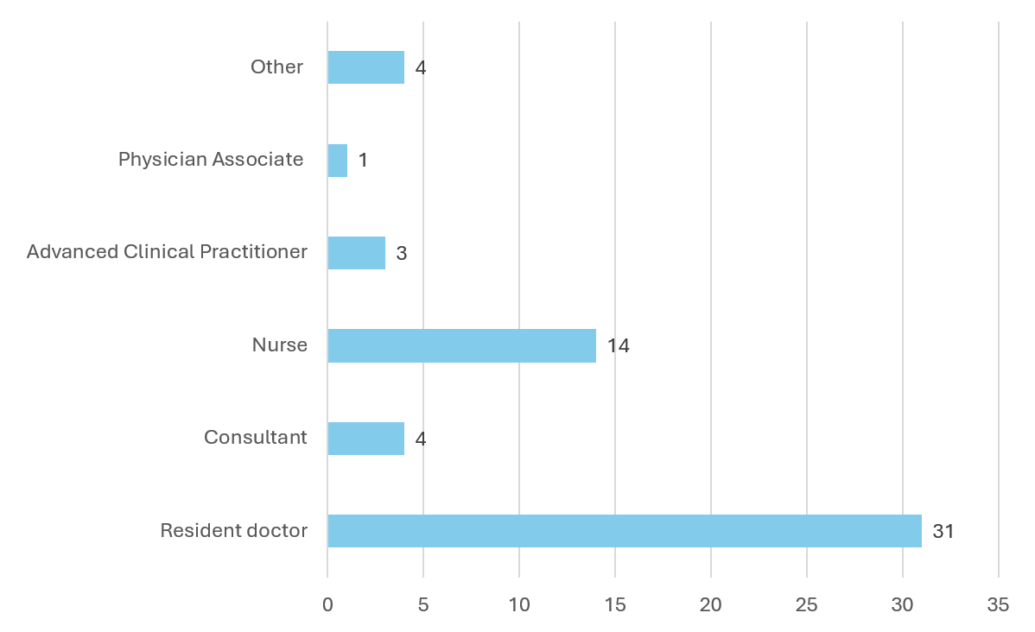
Figure 1. Staff members attending the educational intervention by professional role
Pre-intervention results:
During April 2026, Warrington Hospital's analytics team reported 12,064 blood tests requested across AMU, A5, and A2. Of these, 2,092 were LFTs, accounting for approximately 17% of all blood test requested. A ward-level breakdown is presented in Table 3.
Wards | Total blood orders | Total LFT orders | Percentage of LFT orders
AMU | 5398 | 1007 | 19%
A5 | 3704 | 609 | 16%
A2 | 2962 | 476 | 16%
Table 3. Total LFT requests by ward in April 2026
A retrospective baseline data collection was conducted between 13 and 26 April 2026. A total of 300 LFT requests were reviewed, comprising 100 requests from each ward. Overall, 60% of LFT requested during this period were deemed inappropriate. A ward-level breakdown is presented in Figure 2.
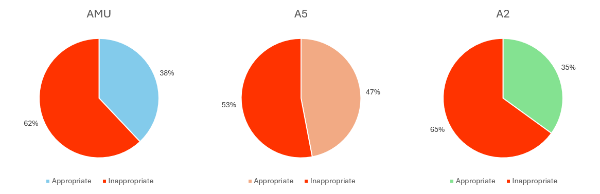
Figure 2. Appropriate and inappropriate LFT requests by ward between 13 and 26 April 2026
Post-intervention results:
In June 2026, following completion of the educational intervention, Warrington Hospital's analytics team reported 10,974 blood tests requested across AMU, A5, and A2. Of these, 1,618 were LFTs, accounting for approximately 15% of all blood test requested. A ward-level breakdown is presented in Table 4.
Wards | Total blood orders | Total LFT orders | Percentage of LFT orders
AMU | 5501 | 981 | 16%
A5 | 3192 | 516 | 16%
A2 | 2281 | 116 | 5%
Table 4. Total LFT requests by ward in June 2026
Post-intervention data collection was conducted between 1 and 14 June 2026. A total of 240 LFT requests were reviewed, comprising 100 requests from AMU, 100 from A5, and 40 from A2, as no further LFT requests were made on this ward during the two-week period. Of these, 45% were deemed inappropriate, demonstrating a 25% reduction in unnecessary testing compared with baseline results. A ward-level breakdown is presented in Figure 3.
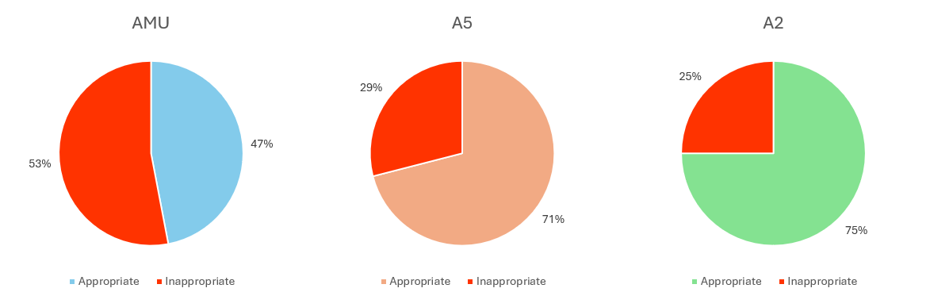 Figure 3. Appropriate and inappropriate LFT requests by ward between 1 and 14 June 2026
Patient outcomes
The post-intervention results demonstrated a 25% relative reduction in unnecessary testing, with the proportion of inappropriate LFT requests decreasing from 60% to 45%. This 15 percentage-point reduction represents LFTs that would previously have been considered inappropriate and therefore unnecessary. Avoiding these tests reduced the potential for harm associated with unnecessary investigations and limited testing that was unlikely to provide meaningful information to support patient management.

Nonetheless, the extent to which reducing inappropriate LFT requests decreased patient harm by avoiding unnecessary diagnostic cascades and better directing healthcare resources is difficult to establish. However, no incidents relating to decreased blood testing were reported across Wards AMU, A2 and A5 in June or July 2026, suggesting that, while the harm avoided cannot be quantified, the intervention did not result in any reported adverse outcomes.
Environmental sustainability
By extrapolating the percentage of inappropriate LFTs identified per ward to the total number of LFTs requested during the 2025–2026 tax year (April 2025 to March 2026), the annual number of inappropriate LFTs requested was estimated (Table 5).
Wards | Total number of LFTs requested per year | % Inappropriate | Number of inappropriate tests
AMU | 12483 | 62 | 7739
A5 | 6076 | 53 | 3220
A2 | 5783 | 65 | 3758
Table 5. Number of inappropriate tests per year by ward
Based on emissions of 0.344 kgCO₂e per LFT sample analysed, the maximum potential avoided emissions per year from baseline, if 100% of inappropriate tests were eliminated, are 5,062.7 kgCO₂e. However, applying the achieved 25% reduction in inappropriately requested LFTs, the potential annual emissions avoided are 1,265.7 kgCO₂e.
Economic sustainability
As per the above, based on the baseline findings and applying the observed 25% reduction in unnecessary testing achieved through the project, it is estimated that approximately 3,680 inappropriate LFT requests could be avoided annually across the three wards.
Based on reagent costs alone, this would result in an estimated annual saving of approximately £368. However, when the estimated inpatient cost of £1.82 per LFT is considered, the projected annual saving increases to approximately £6,698 in cash-releasing savings.
Social sustainability
Patient perspective survey
A small sample of inpatients was randomly selected to participate in the survey, comprising five patients from each ward, 15 patients in total. Of these, 14 participants agreed that the number of blood tests performed on the wards was mostly or completely acceptable.
Potential issues associated with repeat blood tests were also explored. Eight participants reported no issues, while six reported bruising, three reported pain and discomfort, and two reported anxiety. These responses were not specific to LFTs.
When asked whether they would support doctors in reducing unnecessary testing, more than two-thirds of participants responded positively, citing reduced NHS costs, decreased staff workload, and improved patient comfort as the main perceived benefits.
Staff perspective survey
All 57 staff members who attended the teaching session completed the survey. More than 80% agreed that LFTs were requested more often than necessary, either often or very often.
More than half of respondents attributed unnecessary repeat testing primarily to the culture of routine daily blood tests and a lack of awareness of minimal retesting intervals. Fear of missing patient deterioration, requests copied from previous blood orders, and the ease of requesting tests electronically were also identified as important contributing factors. A complete breakdown of responses is presented in Figure 4.
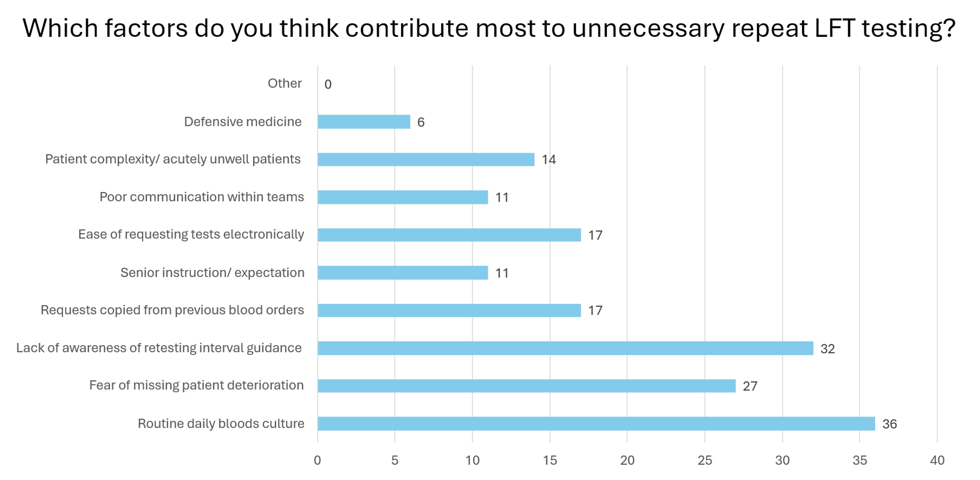
Figure 4. Staff-reported factors contributing to unnecessary repeat LFT requests
When asked about the impact of unnecessary testing, staff identified increased healthcare costs, increased staff workload, and the risk of incidental or false-positive findings as important repercussions. A complete breakdown of responses is presented in Figure 5.
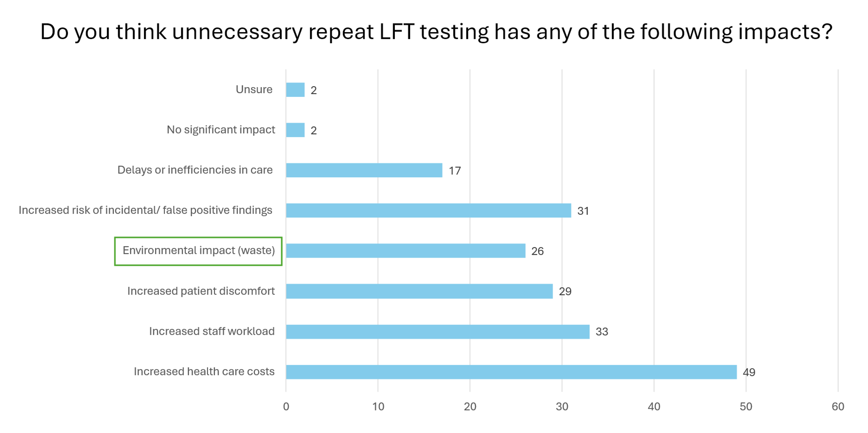Figure 5. Staff-reported impacts of unnecessary repeat LFT requests
Furthermore, almost three-quarters of staff agreed that reducing unnecessary LFT requests should be a departmental priority. However, almost three-quarters were unaware of the recommended minimal retesting intervals. When asked about potential solutions, the majority suggested promoting education on testing guidelines and improving communication between team members.
Discussion
Although overutilisation of LFTs had been identified in routine clinical practice, the baseline data collection revealed unexpectedly high rates of unnecessary testing, consistent with estimates reported in the literature (Koch et al., 2018; Barratt et al., 2022). Following a single QIP cycle, a total 25% reduction in unnecessary testing was achieved, meeting the project’s aim. However, the degree of improvement varied between wards. AMU showed the smallest reduction (15%), whereas A5 and A2 demonstrated reductions of 45% and 62%, respectively, both achieving rates of unnecessary testing below the averages reported in the literature.

This difference may be attributed to the allocation of the core project team. One team member was based in A5, while three members were rotating through A2. In contrast, no team members were based in AMU, which may have resulted in less reinforcement of the intervention among staff. The patient population in AMU should also be considered, as it typically includes a higher proportion of acutely unwell patients, with increased patient turnover and greater diagnostic uncertainty. This may contribute to clinicians' fear of missing patient deterioration, which was identified as the third most common perceived cause of unnecessary testing in the staff survey.

Regarding the patient perspective on unnecessary testing, the vast majority of patients considered the number of blood tests performed during their admission to be acceptable. Despite this, most patients supported reducing the frequency of blood tests when deemed unnecessary by clinicians. This is consistent with studies reporting that the general British public trusts healthcare professionals to make appropriate decisions regarding their care (Carmichael, 2019; Ipsos, 2025).

It is also noteworthy that none of the patients identified reduced medical waste or environmental impact as a perceived benefit of reducing unnecessary testing. This suggests that greater public engagement and education regarding the environmental impact of healthcare may be required to help achieve the NHS net zero target by 2040.

In contrast to patients, clinical staff agreed that unnecessary testing is an issue in clinical practice and identified routine daily bloods culture as the main driver. Most staff also agreed that improving the utilisation of LFTs should be a priority, recognising the social, financial, and environmental burden associated with unnecessary testing.

Education on retesting guidelines was the most frequently suggested solution and was well received, demonstrating effectiveness in improving LFT requesting practices. However, despite staff recognising the issue and supporting education to drive meaningful change, delivering the teaching sessions proved challenging because of patient acuity and workload. This was further compounded by frequent staff turnover, including day and night shift rotations, locum staffing, and annual leave, making it difficult to reach all staff members.

These findings suggest that clinical staff are willing to engage in initiatives to improve the quality of care and value opportunities for further education. However, protected time is required to support educational interventions, and education should be recognised as an investment in improving healthcare quality.

For the second cycle of the QIP, the focus will be on sustaining the improvements achieved by identifying staff members within each ward and recruiting them as champions to support ongoing education, initially focusing on LFTs, with scope for expansion to other blood tests and wards if successful. This approach will help reinforce minimal retesting practices and ensure that new and rotating staff have opportunities to learn and apply these guidelines.

This project also initiated discussions between Warrington Hospital’s Gastroenterology and Biochemistry departments regarding a review of the Trust’s LFT panel. As previously mentioned, Warrington’s LFT panel is extensive, including total bilirubin, ALP, GGT, AST, ALT, total protein, and albumin. The aim would be to align the local LFT panel with the British Society of Gastroenterology guideline (2018), which recommends that initial investigations for liver disease include bilirubin, ALP, GGT, ALT, and albumin. AST and total protein could then be requested as separate tests when clinically indicated.
By doing so, the financial and environmental impact associated with the processing of AST and total protein could be significantly reduced. Approximately 360,000 LFT requests are placed for patients within North Cheshire and Mersey NHS Foundation Trust each year. Removing AST and total protein from the LFT panel could reduce the total reagent cost per LFT from £0.095 to £0.080, representing a saving of £0.015 per test and an estimated annual saving of approximately £5,400 across the Trust.
Additionally, this review could reduce the environmental impact of each LFT from approximately 0.344 kgCO₂e to 0.260 kgCO₂e. The analysis of AST and total protein, including the associated reagents and packaging, produces approximately 0.054 kgCO₂e and 0.030 kgCO₂e per LFT, respectively. This represents a saving of 0.084 kgCO₂e per test and an estimated annual reduction of approximately 30,240 kgCO₂e.
Further discussion will be required to consider the practicalities of implementation, including potential barriers such as changes to funding arrangements and existing laboratory or supplier contracts. Engagement with relevant stakeholders across clinical, laboratory, management, and governance teams will also be essential to assess the feasibility of the proposed change.
Conclusion
Going into this project as medical clinicians, our team had some understanding of the burden inappropriate LFTs create. However, developing this project gave us a much greater appreciation of the scale of the processes surrounding the request and analysis of LFTs, and the wide-reaching impact our clinical practices can have. We gained a deeper understanding of how a clinical decision to request a blood test triggers the work of multiple departments, and how complex their interactions can be when trying to create change.
Nonetheless, staff members across the different departments were welcoming and supportive throughout the project, facilitating our investigations into the processes surrounding LFTs and helping us to uncover their true burden. They were also receptive to learning about minimal retesting intervals and the impact of unnecessary testing, and supported the intervention by being open to changes in their usual practice.
This was reflected in our results, where, after just one Quality Improvement Cycle, we achieved a 25% reduction in inappropriate LFT testing. If these changes are maintained, this could result in annual savings of approximately £6,698 and annual emissions reductions of 1,265.7 kgCO₂e, without accounting for staff time or the potential avoidance of unnecessary diagnostic cascades.
Our results demonstrate that projects such as this, particularly those focused on education to improve testing practices and promote responsible use of healthcare resources, are worth investing in. Supporting care providers locally by providing protected time for education and implementation may help facilitate these changes. By sharing this project and its findings more widely, we hope to encourage reflection and, ultimately, greater support for more sustainable medical practices.

References:
Barratt, A. L., Bell, K. J., Charlesworth, K. and McGain, F. (2022) ‘High value health care is low carbon health care’, The Medical Journal of Australia, 216(2), pp. 67–68. doi:10.5694/mja2.51331.
British Society of Gastroenterology (2018) Guidelines on the management of abnormal liver blood tests. London: BSG. Available at: https://www.bsg.org.uk/getmedia/b51bdc64-7145-43ad-828b-21f473b0a918/Guidelines-on-the-management-of-abnormal-liver-blood-tests.pdfopen_in_new
British Society of Gastroenterology (2025) Getting ahead of the curve: summary and recommendations. Available at: https://www.bsg.org.uk/getmedia/99cfed86-25e3-4d93-9e87-75bb8a22e8b1/Getting-Ahead-of-the-Curve-Summary-and-Recommendations.pdfopen_in_new
Carbon Footprint Ltd (no date) Energy consumption and carbon footprint. Available at: Carbon Footprint Ltd
Carmichael, F. (2019) Who do you trust for health advice? BBC News, 19 June. Available at: BBC News article
Carter, C. (2006) Report of the review of NHS pathology services in England: Independent review for the Department of Health. Report No. 275515. London: Department of Health.
Hale, I. and Green, S. (2025) ‘Reducing the environmental burden of unnecessary investigations’, Canadian Family Physician, 71(2), pp. 80–84. doi:10.46747/cfp.710280.
Ipsos (2025) Ipsos Veracity Index 2025. Available at: https://www.ipsos.com/en-uk/ipsos-veracity-index-2025open_in_new
Kannan, P., Mathew, S. and Griffith, B. (2025) “Pause the Draws: A Quality Improvement Project to Minimize Unnecessary Liver Function Tests in a Small District General Hospital,” Curēus (Palo Alto, CA), 17(11), p. e97681.
Koch, C., Roberts, K., Petruccelli, C. and Morgan, D. J. (2018) The frequency of unnecessary testing in hospitalized patients, American Journal of Medicine, 131(5), pp. 500–503.
Miyakis, S., Karamanof, G., Liontos, M. et al. (2006) 'Factors contributing to inappropriate ordering of tests in an academic medical department and the effect of an educational feedback strategy', Postgraduate Medical Journal, 82(974), pp. 823–829.
Mughal, Z., Narayanan, A., Gupta, V. and Reay-Jones, N. (2016) ‘Clinical need-directed blood tests: a step in saving the NHS?’, Annals of Clinical Biochemistry, 53(5), pp. 568–574. doi:10.1177/0004563215617782.
Müskens, J. L. J. M., Kool, R. B., van Dulmen, S. A. and Westert, G. P. (2022) ‘Overuse of diagnostic testing in healthcare: a systematic review’, BMJ Quality & Safety, 31(1), pp. 54–63.
Newsome, P. N., et al. (2018) Guidelines on the management of abnormal liver blood tests, Gut, 67(1), pp. 6–19. doi:10.1136/gutjnl-2017-314924.
NHS England (2025) Five years of a greener NHS: progress and forward look. Available at: https://www.england.nhs.uk/long-read/five-years-greener-nhs-progress-forward-look/open_in_new
NHS England (2025) National commitments. Greener NHS. Available at: https://www.england.nhs.uk/greenernhs/national-ambition/national-commitments/open_in_new
Schreiner, A. D., Mauldin, P. D., Moran, W. P., Durkalski Mauldin, V., Zhang, J., Schumann, S. O., Heincelman, M. E., Marsden, J. and Rockey, D. C. (2018) Assessing the burden of abnormal liver function tests and the role of the electronic health record: a retrospective study, The American Journal of the Medical Sciences, 355(6), pp. 537–543. doi:10.1016/j.amjms.2018.02.005.
Sinitsky, L. and Brierley, J. (2017) ‘Reducing the number of unnecessary liver function tests requested on the Paediatric Intensive Care Unit’, BMJ Quality Improvement Reports, 6(1), p. u214071.w5561. doi:10.1136/bmjquality.u214071.w5561.
Spoyalo, K., Lalande, A., Rizan, C., Park, S., Simons, J., Dawe, P., Brown, C. J., Lillywhite, R. and MacNeill, A. J. (2023) ‘Patient, hospital and environmental costs of unnecessary bloodwork: capturing the triple bottom line of inappropriate care in general surgery patients’, BMJ Open Quality, 12(3), e002316. doi:10.1136/bmjoq-2023-002316.
Tennison, I., Roschnik, S., Ashby, B. et al. (2021) 'Health care's response to climate change: a carbon footprint assessment of the NHS in England', The Lancet Planetary Health, 5(2), pp. e84–e92.
The King's Fund (2025) Waiting times for elective (non-urgent) treatment: Referral to Treatment (RTT). Available at: https://www.kingsfund.org.uk/insight-and-analysis/data-and-charts/waiting-times-non-urgent-treatmentopen_in_new
The Royal College of Pathologists (2021) Pathology facts and figures. Available at: https://www.rcpath.org/discover-pathology/news/fact-sheets/pathology-facts-and-figures-.htmlopen_in_new
Thurm, M., Craggs, H., Watts, M. and Brooks, A. (2021) ‘Reducing the number of unnecessary laboratory tests within hospital through the use of educational interventions’, Annals of Clinical Biochemistry, 58(6), pp. 632–637. doi:10.1177/00045632211040670.
Appendices
Appendix 1: Project Activities and Team Engagement
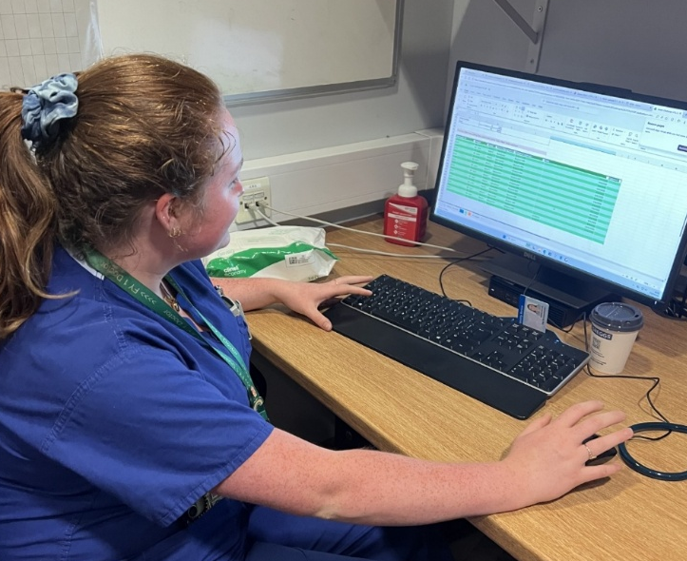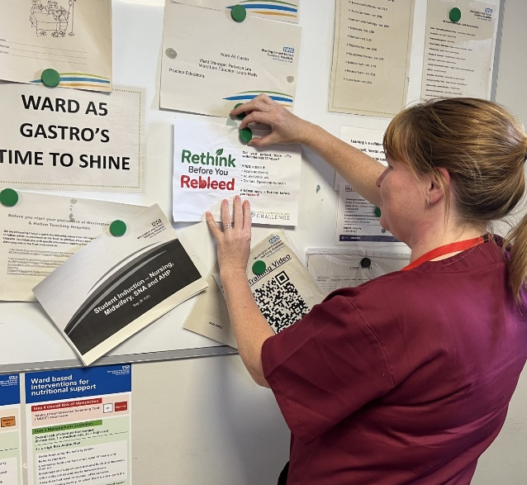
Figure 6. Project activities: Kate collecting baseline data (left) and Holly displaying posters reminding staff of minimum retesting intervals (right).
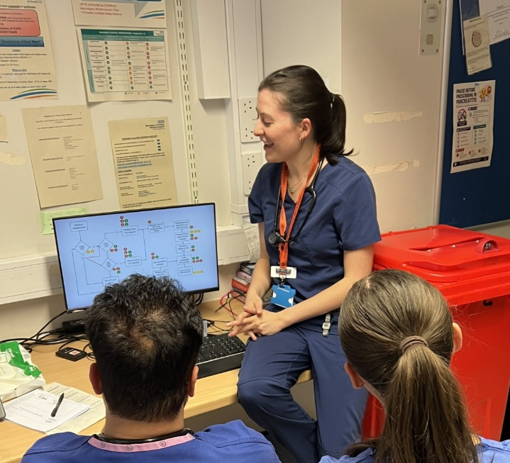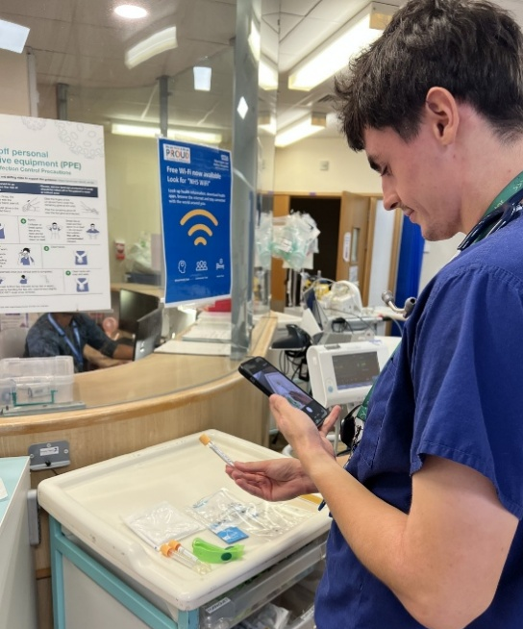
Figure 7. Project activities: Paola delivering a teaching session to staff on improving the clinical utilisation of LFTs (left) and David photographing the equipment used for blood collection to facilitate carbon foot printing (right).
Appendix 2: LFT Process Map
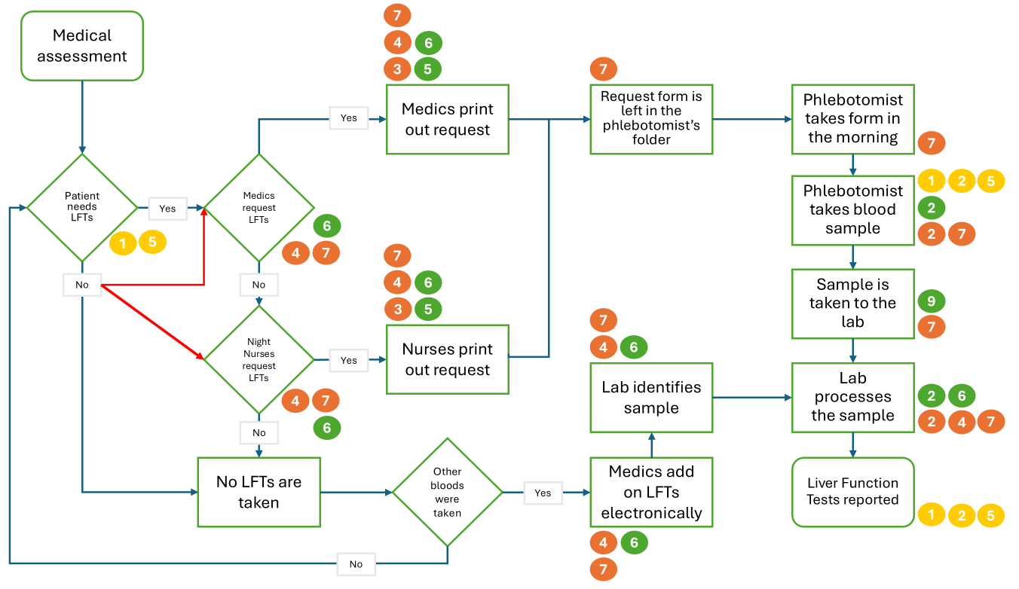
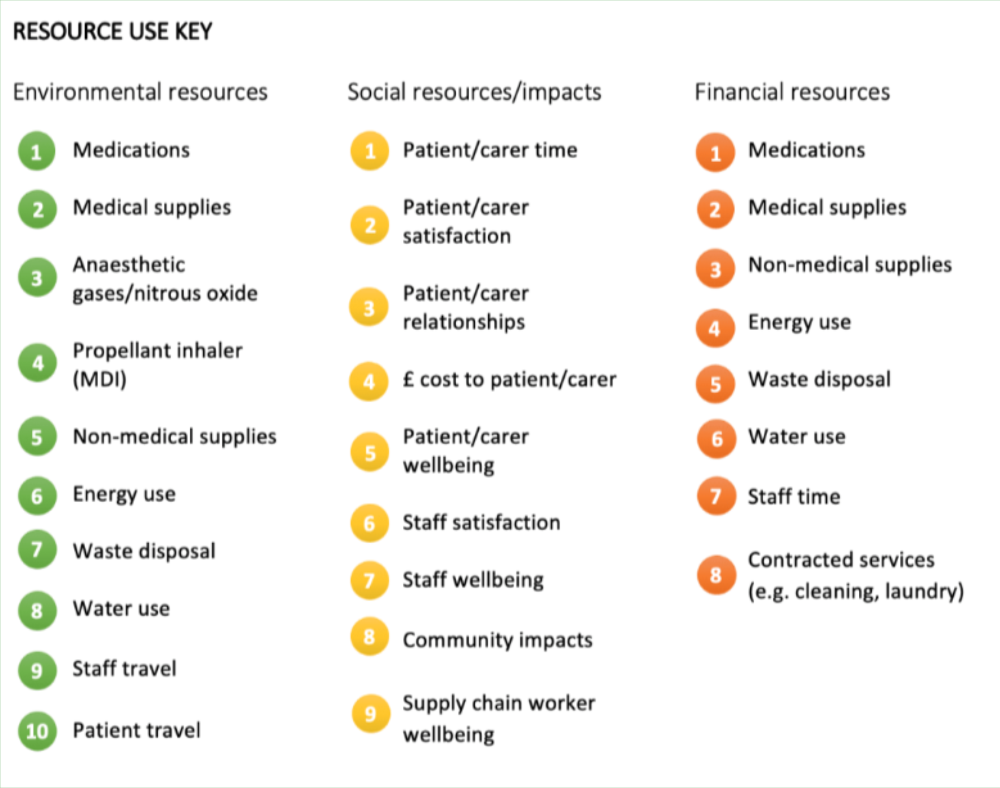

Appendix 3: Environmental Impact Assessment
Environmental impact assessment of LFT collection and analysis, conducted by Dr Matthew Sawyer, Centre for Sustainable Healthcare.
Environmental impact – North Cheshire and Mersey LFT analysis

Methodology
A cradle-to-grave carbon footprint analysis was used to estimate the items greenhouse gas (GHG) emissions. Data was provided on the number and processes for collection and analysis of liver function tests. These were carbon footprinted using a process- based carbon footprint analysis. Items were weighed by the team and materials identified.

Data was obtained from previous studies by the Centre for Sustainable Healthcare and other references. Where data was unavailable, calculations were made based on the weight and material of the product. Material weights were converted into GHG emissions using emission conversion factors taken from the Department of Energy Security and Net Zero (DESNZ)’s Greenhouse Gas Reporting Conversion Factors 2026 database (https://www.gov.uk/government/publications/greenhouse-gas-reporting-conversion-factors-2026), ICE V4.0 database and primary research papers and LCAs. The analysis included GHG emissions associated with primary materials production, transport, and disposal.
Materials
Material emissions are calculated by the weight of the material, emission factor of the material and number of items.
Total emissions = weight of material * material emission factor
Waste
For end-of-life treatment, disposable equipment was assumed to be disposed of as offensive waste, while any card/paper packaging waste was assumed to be dry mixed recyclable with the corresponding emission factors taken from Rizan et al., 2020. The carbon footprint of waste disposal of the items was based on Rizan et al., 2020 carbon footprint of high temperature incineration for clinical waste.

Waste emissions are calculated by amount of waste (tonnes) and the UK emission factor of average emissions by waste stream.
Total emissions = volume of waste * waste stream emission factor
The emission factor for clinical waste is 1074 kgCO₂e, infectious waste is 569 kgCO₂e, dry mixed recycling is 172 kgCO₂e and domestic waste is 172 kgCO₂e.

Activity Data
Data was collected on the total number of liver function tests taken annually. A sample audit was conducted, and the team reviewed the clinical indication to determine whether the test was clinically indicated and appropriate. The results are shown in Table 1.
Table 1. Number of blood tests taken per ward annually and the proportion deemed appropriate and inappropriate from the sample audit.
Wards | Total number of blood tests taken per year | Number of LFT tests requested in sample audit | % deemed inappropriate | % deemed appropriate
AMU | 12483 | 1007 | 62 | 38
A5 | 6076 | 609 | 53 | 47
A2 | 5783 | 476 | 65 | 35

Emissions associated with analysis of liver function tests
There are emissions associated with the taking of the blood sample including raw materials and production of the consumables used and those from the disposal of the waste. Additionally, there are emissions associated with the analysis of the blood sample.
Results
The taking of the blood sample was analysed. An inventory of the consumable equipment used was provided. This was analysed for data on the weights and materials or carbon footprint of the item if already known from previous green team competitions.
Table 2. Components of blood sampling, with emission factors per item and total carbon emissions.
Blood sampling equipment and source material if not provided | Number of items used | Carbon emission factor per item (kgCO₂e /item use) | Carbon emissions for item (kgCO₂e) | Reference
Nonsterile glove | 2 | 0.026 | 0.052 | Rizan *
Single use plastic apron | 1 | 0.065 | 0.065 | Rizan *
Vacutainer needle | 1 | 0.003 | 0.003 | DESNZ
Vacutainer holder  https://cdn.cosanum.ch/shop/tis-364815-292744.pdf | 1 | 0.007 | 0.007 | DESNZ
Cotton ball | 1 | 0.005 | 0.005 | MedZero **
Preinjection swab | 1 | 0.033 | 0.033 | CSH project
Biochemistry tube | 1 | 0.021 | 0.021 | DESNZ
Transpore tape roll | 1 | 0.001 | 0.001 | MedZero **
Butterfly needle with vacutainer holder attached | 1 | 0.010 | 0.010 | DESNZ
Torniquet | 1 | 0.025 | 0.025 | CSH Project
Plastic bag for sample transportation | 1 | 0.009 | 0.009 | DESNZ
Sharps container 2.5l (***) | 1 | 0.597 | 0.597 | DESNZ
(* C Rizan, M Reed, M Bhutta. Environmental impact of Personal Protective Equipment supplied to health and social care services in England in the first six months of the COVID-19 pandemic. 2021)
(**MedZero https://www.medzerocarbon.com/)
(*** The empty sharps container weight is 232g (https://daniels.co.uk/product/sharpsguard-eco-orange-2-5/). The Sharps container has a maximum filling weight of 1kg, and a gross filled weight of 1.23kg. If only sharp items were placed in the container for disposal, the weight of consumables is approximately 10g. Therefore, sharps from 100 blood tests would fill the sharps container. Attributing weight – and emissions – to the sharps bin per blood tests shows a weight of 2.3g empty (232g/100) and 12.3g (1232g/100) filled with emissions of 6 gCO₂e (597 gCO₂e /100 tests) from the container itself.)
Hand washing
Prior to taking a blood test, hands are cleaned. There are several different options available as discussed in https://pmc.ncbi.nlm.nih.gov/articles/PMC8865176/.
- Hand washing with liquid soap, emissions are 0.012 kgCO₂e
- Hand washing with a bar of soap, emissions are 0.006 kgCO₂e
- Hand cleaning with an ethanol-based gel, emissions are 0.004 kgCO₂e
For this project, it is assumed that prior to taking blood, hands are cleaned with ethanol-based hand gel.
Emissions per blood test for raw material and production
The items required for blood taking are not each used every time. For example, 95% of the time a standard vacutainer and needle are used but 5% of the time butterfly needle is required. The frequency of use and emissions are shown in Table 3 for the consumable equipment.
Table 3. Emissions associated with consumable equipment used.
Blood sampling equipment | Carbon emissions for item (kgCO₂e) | Frequency used (%) | Emissions (kgCO₂e)
Hand cleaning with an ethanol-based gel | 0.004 | 100 | 0.004
Nonsterile glove | 0.052 | 100 | 0.0520
Single use plastic apron | 0.065 | 20 | 0.0130
Vacutainer needle | 0.003 | 95 | 0.00277
Vacutainer holder | 0.007 | 95 | 0.00676
Cotton ball | 0.005 | 100 | 0.00493
Preinjection swab | 0.033 | 100 | 0.0328
Biochemistry tube | 0.021 | 100 | 0.0210
Transpore tape roll | 0.001 | 100 | 0.00149
Butterfly needle with vacutainer holder attached | 0.010 | 5 | 0.00050
Torniquet | 0.025 | 100 | 0.0249
Plastic bag for sample transportation | 0.009 | 100 | 0.009
Sharps container 2.5l | 0.597 | 100 | 0.00597
Total emissions from raw materials and production accounting for the variable proportions of equipment used are 0.179 kgCO₂e per blood test.

Waste
Waste emissions are calculated by amount of waste (tonnes) and the UK emission factor of average emissions by waste stream.
Total emissions = volume of waste * waste stream emission factor
- Weight of the consumable items including proportion of the sharps bin is around 64g.
- The emission factor for clinical waste and sharps disposal is 1074 kgCO₂e.
Emissions are 0.000064*1074 = 0.069 kgCO₂e per blood test.
Summary
Carbon footprint for raw materials, production (0.179 kgCO₂e) and waste disposal (0.069 kgCO₂e) per LFT blood test is 0.248 kgCO₂e.
Analysis of the liver function test
The steps taken in the process for analysis of the LFT sample are shown in Table 4.
Table 4. Process of analysis and whether emissions have been included in the calculations
Process step | Comments | Inclusion in carbon footprint
1. The samples collected will reach the laboratory either by porter or by pneumatic tube system. | The pneumatic system will have been installed previously. Although ongoing maintenance is required calculating attributable emissions is not possible within this project. | No.
2. The samples will be collected in a grate that can be inserted into the circuit, this grate can be reused. | No as in use for all blood tests and is reused. | No.
3. In the circuit each sample will be recognized by its bar code and will be sent to be processed depending what test is needed. |  | No.
4. The samples reach the centrifuge. LFTs take 6 minutes to centrifuge at 3500 rpm. The make is Siemens. | Energy is required to run the centrifuge. | Energy use included.
5. The centrifuged sample will go on to be processed in a different machine that contains the reactors for LFTs and different biochemistry tests. | Capital emissions for equipment are not included as machine in use for multiple specimens. | No.
6. Each machine can be loaded with different reactants. For the LFTs, reactant(s) for each individual test (albumin, bilirubin, AST, ALT, GGT, ALP, and total proteins.) are required | Data on reagents used is available. | Reagents included.
7. After the sample is processed it will complete the circuit and will be closed off with an aluminium sheet and stored for 6 days. If any test needs to be added to the sample, it will run the circuit again (without being centrifuged). | Storage facilities, energy rating etc are not known. | No.
8. After 6 days the samples in the test tubes will be discarded in a plastic waste container. | Weight of blood test tube (6.8g) and specimen (5g) are likely disposed of via the clinical waste stream. | Waste included.
9. Once the reactants have been used, they will be discarded in a plastic waste container if they are sharp or leaking (small individual reactants) or in a waste bag if they are sealed (bigger reactants used for all samples). | Not included separately to the test tube and specimen. | No.
The two components for analysis are the emissions from the energy used to process the sample and the reagents consumed per analysis.
Energy use
Data taken from Patient, hospital and environmental costs of unnecessary bloodwork: capturing the triple bottom line of inappropriate care in general surgery patients | BMJ Open Quality (https://bmjopenquality.bmj.com/content/12/3/e002316#T3) and the supplementary data file 10 shows the energy used per test based on a Siemens StreamLab set up is summarised in Table 5.
Table 5. Emissions from energy used to analyse each test parameter for liver function tests.
Test parameter | Energy used per test (kWh) | Time to run the test (mins) | Emissions based on UK electricity emissions factor (kgCO₂e)
Albumin | 0.2 | 2.2 | 0.001056
Alkaline Phosphatase | 0.8 | 7.2 | 0.013824
ALT | 0.6 | 5.6 | 0.008064
AST | 0.6 | 5.3 | 0.007632
Gamma GT | 0.2 | 1.9 | 0.000912
Total Bilirubin | 0.8 | 7.2 | 0.013824
Total Protein | 0.4 | 3.8 | 0.003648
Total | 3.6 |  | 0.04896
Emissions = mins/60 * energy used to run the test * emission factor for electricity.
The emissions factor for UK electricity is 0.144 kgCO₂e /kWh.
Emissions from energy consumed to run the analysis of a LFT is 0.049 kgCO₂e per test in the UK.
Centrifuge
- Energy used by centrifuge estimated to be between 0.02 and 0.05kWh.
- Emissions per centrifuge spin = 0.007 kgCO₂e (7 gCO₂e) using higher energy use.
- It is not known how many samples are spun simultaneously but data from Patient, hospital and environmental costs of unnecessary bloodwork: capturing the triple bottom line of inappropriate care in general surgery patients | BMJ Open Quality (https://bmjopenquality.bmj.com/content/12/3/e002316#T3) suggests 48.
- Emissions per sample are 7/48 = 0.15 gCO₂e per sample.
Reagent
Test parameters use a variety of reagents. Taken from Supplemental Data file 5, reagents used for LFTs are described. Using the reagent for an ALP assay as an example, the emissions for each reagent were calculated as follows:
- Step 1: Convert concentrations to mass per litre
- Step 2. Determine mid-range representative emissions factors
- Step 3: Carbon footprint contribution
The results are shown in Table 6.
Table 6. Component of an ALP assay reagent, with the molecular weight (MW), concentration
Component of ALP test reagent | MW (g/mol) | Concentration | Step 1.  Mass g/L | Step 2.  Mid-range emission factors (kgCO₂e) (*) | Step 3.  Carbon footprint contribution (kg CO₂e/L)
AMP | 89.14 | 3.0 M | 267.4 | 6 | 1.6
Magnesium acetate | 142.4 | 8 mmol/L | 1.14 | 3 | 0.003
Zinc sulfate | 161.4 | 4 mmol/L | 0.65 | 3 | 0.002
HEDTA | 278.3 | 8 mmol/L | 2.23 | 7 | 0.016
p-NPP | ~219.1 | 101.6 mmol/L | 22.3 | 15 | 0.335
(* this is calculated by considering the inputs of chemical feedstocks, hydrogen, process heat and electricity - such as for AMP, production through 2-methyl-2-nitro-1-propanol followed by hydrogenation to AMP- and typical emission factors for each).
Estimated total is 1.96 kgCO₂e /litre but with a range from 1.8-2.3 kgCO₂e/litre. A central estimate of 2 kgCO₂e/litre was used in the calculations below.
This process was repeated for each reagent with the results are shown in Table 7.
Table 7. Emissions attributable for each test reagent and packaging based on reagent components, weight and a calculated emission factor per litre. Density of the reagent of 1ml/g was assumed.
 | Reagent components | Weight (g) | Emissions per 1 litre reagent (kgCO₂e) | Emissions attributable to the reagent (kgCO₂e)
Flex Cartridge ALP | Reagents [AMP 3.0M, Magnesium acetate 8.0mmol/L, Zinc sulfate 4.0mmol/L, HEDTA 8.0mmol/L, p-NPP buffer 101.6mmol/L] | 0.01 | 2.0 | 0.02
Flex Cartridge ALP | Plastic | 0.05
Flex Cartridge ALP | Plastic* | 0.004
Flex Cartridge ALP | Cardboard* | 0.02
Flex Cartridge ALT | Reagents [Tris buffer 1200 mmol/L, LDH 7712 U/L, NADH 0.57mmol/L, P5P 0.39mmol/L, α-KG 61mmol/L, Alanine 1170mmol/L] | 0.1 | 1.74 | 0.174
Flex Cartridge ALT | Plastic | 0.13
Flex Cartridge ALT | Plastic* | 0.01
Flex Cartridge ALT | Cardboard* | 0.04
Flex Cartridge AST | Reagents [MDH 3000 U/L, LDH 900 U/L, NADH 0.21mmol/L, P5P 0.18mmol/L, Aspartic acid 180mmol/L, α-KG 11.5mmol/L] | 0.2 | 0.23 | 0.046
Flex Cartridge AST | Plastic | 0.06
Flex Cartridge AST | Plastic* | 0.01
Flex Cartridge AST | Cardboard* | 0.02
Flex Cartridge Total bilirubin | Reagents [Caffeine 168 mM, Buffer, Na Benzoate 337mM, Disodium EDTA 2.6 mM, Sodium nitrate 72.5 mM, Sulfanilic acid 25.9 mM, Hydrochloric acid 132 mM] | 0.004 | 0.4 | 0.0016
Flex Cartridge Total bilirubin | Plastic | 0.12
Flex Cartridge Total bilirubin | Plastic* | 0.01
Flex Cartridge Total bilirubin | Cardboard* | 0.04
Flex Cartridge GGT | Reagents [GCNA 0.69mg, Glycylglycine 90mM/L] | 0.001 | 0.083 | 0.000083
Flex Cartridge GGT | Plastic | 0.09
Flex Cartridge GGT | Plastic* | 0.01
Flex Cartridge GGT | Cardboard* | 0.06
Flex Cartridge Albumin | Reagents [BCP dye 2.7 x10^-4 M, Acetate buffer, Surfactant, Microbial inhibitor] | 0.3 | 0.036 | 0.0108
Flex Cartridge Albumin | Plastic | 0.04
Flex Cartridge Albumin | Plastic* | 0.003
Flex Cartridge Albumin | Cardboard* | 0.03
Flex Cartridge Total protein | Reagents [Potassium Sodium Tartrate 1.089g/mL, NaOH, Cupric Sulfate 0.015mol/L] | 0.1 | 0.27 | 0.027
Flex Cartridge Total protein | Plastic | 0.06
Flex Cartridge Total protein | Plastic* | 0.01
Flex Cartridge Total protein | Cardboard* | 0.04
(* packaging materials)
Total emissions from the reagent are 0.2795 kgCO₂e per test.
Packaging
The total volume of plastic and cardboard is 0.61g and 0.25g respectively. Emissions using emissions factors of 3,170.5 and 1,287 kgCO₂e /tonne respectively results in emissions of 2.2 gCO₂e per LFT analysis from reagent packaging.
Waste
Sample tube is 6.8g and assuming 5ml of blood, total weight is 11.8g per sample.
Assuming disposal via the clinical waste stream with an emissions factor of 1074 kgCO₂e/t, emissions are 0.0000118*1074 = 0.0127 kgCO₂e per test.
Summary
- Centrifuge 0.00015 kgCO₂e
- Energy use 0.049 kgCO₂e
- Reagent 0.2795 kgCO₂e
- Reagent packaging 0.0022 kgCO₂e
- Sample waste 0.0127 kgCO₂e
Total emissions are 0.344 kgCO₂e for the analysis of a liver function test.
If the blood test was only taken for a LFT, emissions from the phlebotomy equipment add 0.248 kgCO₂e to the emissions per sample.
Conclusion
Avoidable LFT sample analysis
Data was collected on the total number of LFTs requested and those deemed appropriate and shown in Table 1. When extrapolated to all LFT requests over a year, figure is shown in Table 8.
Table 8. Number of inappropriate tests per year by ward
Wards | Total number of LFTs requested per year | % Inappropriate | Number of inappropriate tests
AMU | 12483 | 62 | 7739
A5 | 6076 | 53 | 3220
A2 | 5783 | 65 | 3758

If the emissions from analysing a LFT sample in the lab is 0.344 kgCO₂e/ test, the maximum potential avoided emissions per year from baseline if 100% of inappropriate tests were eliminated are:
- AMU 2662.2 kgCO₂e
- A5 1107.7 kgCO₂e
- A2 1292.8 kgCO₂e
If a reduction of 25% in inappropriately requested LFTs, emissions avoided are
- AMU 665.6 kgCO₂e
- A5 276.9 kgCO₂e
- A2 323.2 kgCO₂e
In total, this equates to 1,265.7 kgCO₂e.

